SMART PHONE
Non-Confidential
With Infrared Thermometer

A New Feature in a Smart Mobile Phone or Tablet – an Infrared Fever Thermometer
Instantly measures body temperature and detects fever with no contact with the patient
From the inventor of the Thermoscan Ear Thermometer

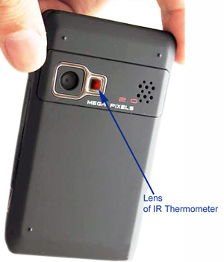
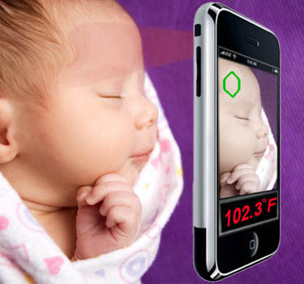

- Patented Technology – U.S. issued and world pending patents
- No comparable products on the market – a great differentiator for a smart phone industry
- Minimal incremental cost
- Quick time to market
- Very easy to use
- Instant response (<1 s)
- Computes the body inner temperature (medical mode)
- Clinical Accuracy meets ISO standards
- Measures temperatures of inanimate objects (buildings, machinery, circuit boards, etc.)
- Small (2.5 mm) infrared (IR) lens is located next to the digital camera lens.
- Technology is expandable to a thermal imaging, UV and EMF pollution exposure and others.

The IP and Technology are available for licensing to qualified companies having significant presence in the market of mobile telephones

For additional information contact Fraden Corporation

(non-confidential technical information is on the next page)
SMART PHONE With built-in Infrared Thermometer
(Non-confidential information)
A breakthrough technology for smart phones since a digital photo camera
From the inventor of the Thermoscan Ear Thermometer.
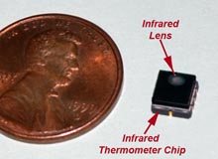
- Patented Technology – (U.S Patent No. 8,275,413) and PCT World patents are on file. The patents cover mobile communication devices capable of receiving and processing external electromagnetic radiation in multiple spectral ranges. These include EMF radiation from high voltage power lines, microwave ovens, Wi-Fi routers, etc. It also covers measurement of UV intensity for beachgoers to limit the sun exposure or select a suntan lotion. In the far-infrared (IR) range it allows a noncontact remote measurement of temperature. Other applications include a thermal imaging for a night vision.
IR Camera in a ceramic packaging
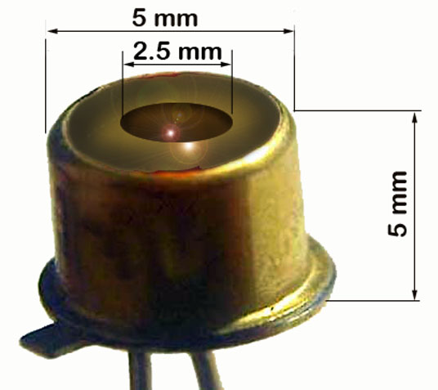
- The first and presumably the most attractive application of the IP is a non-contact IR thermometer for detecting fever in patients of all ages and measuring surface temperatures of inanimate objects, such as machinery, cooking, chemical processes, various electric equipment, construction industry, building wall insulation, adhesive and sealant applications, etc. IR radiation is naturally emanated from any object in relation to its temperature.
- There are several options for very easy IR camera integration. The entire IR thermometer may be packaged into a small ceramic SMD module that contains the IR optics operating in the spectral range from 5 to 15 μm, IR sensor, signal conditioner, ADC, and the I²C serial output circuit. Alternatively, it may be packaged into a TO-46 standard can with the through-hole terminals. Further customization allows reduction of the camera height down to 4 mm. Depending on volume, the total incremental component cost is between US$1.65 and 2.50.
TO-46 Packaging of IR Camera
- An emerging IR technology allows incorporation into a smart phone a thermal imaging camera for a night vision and evaluating heat distribution over object surfaces.
- In a smart phone, the IR camera is positioned optimally close to the built-in digital photo/video camera that during temperature measurement is used for locating part of the object from which the IR signal is detected and measured.
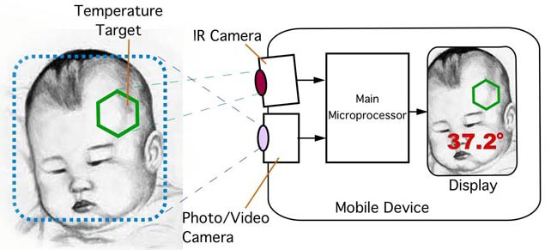
- No additional external components are required. A simplified block-diagram at right shows the interface between the IR camera and main microprocessor of the mobile phone (tablet). Note the green target on a digital image that corresponds to the field of view of the IR camera. It can be manually or automatically positioned. Temperature is computed by the Main Microprocessor from a digital signal received from the IR camera.
- The IR camera has two operating modes: medical temperature and inanimate temperature.
The former makes a single snapshot measurement (IR photo mode) while the latter measures and displays temperature continuously (IR video mode).
- For measuring human temperature, the IR lens should be located from 1 to 15 cm (0.5 – 6”) from the skin. The medical temperature range is from 34 to 42ºC (93 to 108ºF) with the ISO required clinical accuracy of ±0.2ºC (±0.3ºF).
- For measuring inanimate objects, the lens may be positioned at distances from 1 cm (0.5”) to infinity. A surface area of the target from where the IR radiation is collected depends on a distance. Angle of view of the IR objective lens is about 15º.
- Temperature range of the inanimate objects is from -30ºC to +200ºC (-22ºF to 400ºF) with accuracy ranging from ±0.7ºC to ±4ºC (±1ºF to ±7ºF), depending on the object temperature (for the object emissivity 1).
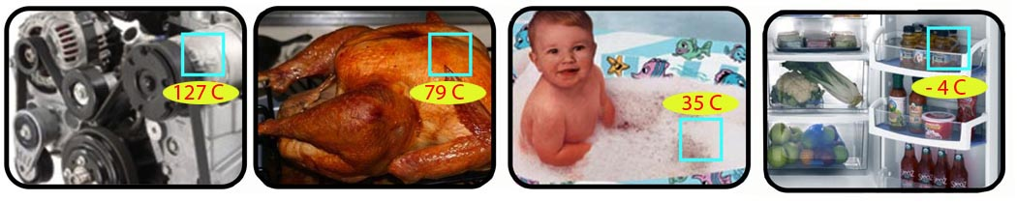
- Illustrations below show simulated screenshots for measuring temperatures of machinery, food, bath water and refrigerator.

