
THOMAS PR TECHIE HOLIDAY GIFT IDEAS 2012
See Product Photos at: http://www.thomas-pr.com/thomaspr/thomasprtechieholidaygiftideas2012.html
Thomas Public Relations www.thomaspr.com announced today Techie Holiday Gift Ideas from GoSmart, SensoGlove, foxL, ArtRage, Kidz Gear, Impecca, Easy-Doks, and The Great Kat for monthly Holiday Gift Guide magazine articles coming out in December.
Please contact Thomas PR if you’d like review copies of any of these products below or need more info: kthomas@thomaspr.com or eyutani@thomaspr.com .
- FOR GOLFERS FROM BEGINNERS TO ADVANCED: SensoGlove Digital Golf Glove

SensoGlove, the world’s first digital golf glove, is the perfect holiday sports gift for golfers of all levels (from beginners to advanced) to learn how to correctly swing the club. SensoGlove has built-in digital sensors that continuously read grip pressure to ensure a consistently accurate, smooth and powerful golf swing. Made of the highest quality cabretta leather, anyone can quickly learn how to hold the club, avoid bad habits and improve every part of their game, from backswing, downswing, impact, follow-through, driving, putting, and chipping.
Pricing: $89
Website: www.sensoglove.com
Available at: www.sensoglove.com and distributors, sales partners, & golf schools around the world
Release: http://www.thomas-pr.com/sensosolutions/sensosolutionssensogloveshipsrelease.html
SensoGlove New Version: http://www.thomas-pr.com/136/photos/sensosolutionssensogloveclubnew.html
http://www.thomas-pr.com/136/photos/sensosolutionssensoglovenew.html
http://www.thomas-pr.com/136/photos/sensosolutionssensoglovenew2.html
http://www.thomas-pr.com/136/photos/sensosolutionssensoglovealonenew.html
SensoGlove Logo: http://www.thomas-pr.com/136/photos/sensosolutionssensoglove.html

- FOR FRIENDS/RELATIVES WITH MULTIPLE PHONES/TABLETS – CHARGES 6 DEVICES AT SAME TIME: Easy-Doks CR34
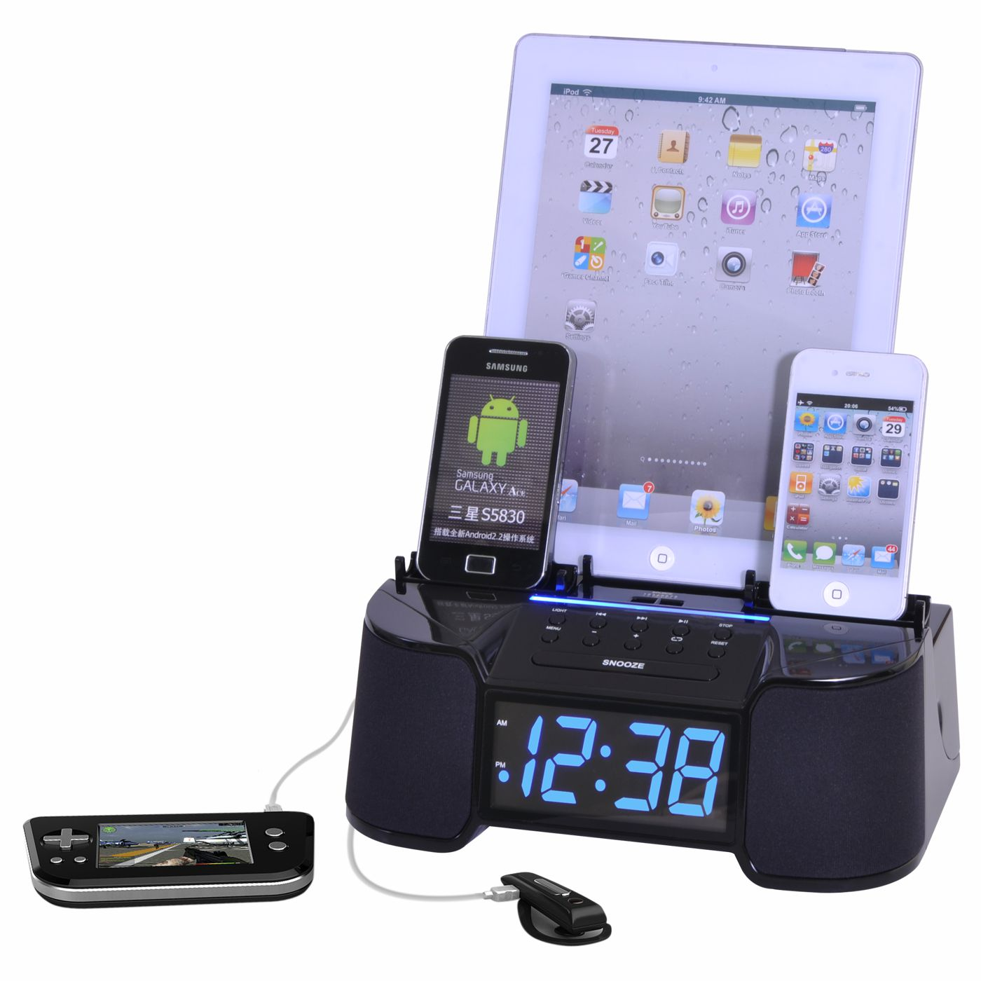
The Easy-Doks CR34 is the essential smart quick charger to charge and dock up to 6 devices simultaneously, neatly and elegantly displaying your devices in one place at all times. Easy-Doks CR34 charges all phones (including iPhones, Androids & Blackberrys), tablets (iPads, Galaxys, etc.), MP3 players (iPods, etc.), headsets, Bluetooth speakers, and more at the same time, for a professional looking charging/docking solution. Easy-Doks uses Smart Current Detection (SCD) Technology to charge each device individually, adjusting the flow to ensure proper charging to each device to avoid harmful over-charging , which reduces battery longevity. It also features a “Tidy-Cable” organizer to keep cables neat and an FM stereo alarm clock radio with remote for waking up with music. In addition, Easy-Doks also allows you to display and play one device on the speaker system while charging the devices at the same time.

Pricing: Easy-Doks CR34 (6 charging ports) $99.99 – CR30 (4 charging ports) $79.99 –
CR15 (1 charging port) $34.99
Website: www.easy-doks.com
Available at: www.easy-doks.com, and major online retailers, including Target.com, Skymall.com, Sears.com, Kmart.com, and Wayfair.com
Release: http://www.thomas-pr.com/easydoks/easydokscr34release.html
Photos:
Easy-Doks CR34: http://www.thomas-pr.com/136/photos/easydokscr34.html
Easy-Doks Logo: http://www.thomas-pr.com/136/photos/easydokslogo.html
- SMARTPHONE CLIP FOR GOLF CARTS, CAR STEERING WHEELS & SHOPPING CARTS FOR QUICK ACCESS: GoSmart Clip for SmartPhones

The GoSmart Clip is a great gift for everyone that needs hands-free access to your smartphone. The GoSmart Clip clips iPhones and other smartphones to golf carts for keeping score of the game, car steering wheels for quick access to GPS directions, store carts for viewing shopping lists, baby strollers for soothing music for baby, or anywhere for hands-free talking to friends and more. The GoSmart Clip is available in red or black and fits most smartphones at 4” to 5” long (100mm - 125mm) tall and less than 0.75” thick (20mm), including iPhones and Androids.
Pricing: $24.95 (in red or black)
Website: www.justgosmart.com
Available at: http://www.gosmartclip.com and www.Amazon.com
Release: http://www.thomas-pr.com/gosmart/gosmartcliprelease.html
Photos:
GoSmart Clip on Golf Cart App: http://www.thomas-pr.com/136/photos/gosmartclipgolf.html
GoSmart Clip on Golf Cart Screen: http://www.thomas-pr.com/136/photos/gosmartclipgolfscreen.html
GoSmart Clip on Shopping Cart: http://www.thomas-pr.com/136/photos/gosmartclipshopping.html
Facebook: http://www.facebook.com/JustGoSmart
- FOR PRECISE PAINTING, WRITING, & CLICKING ON AN IPAD, SMARTPHONE OR TOUCHSCREEN: GoSmart Stylus
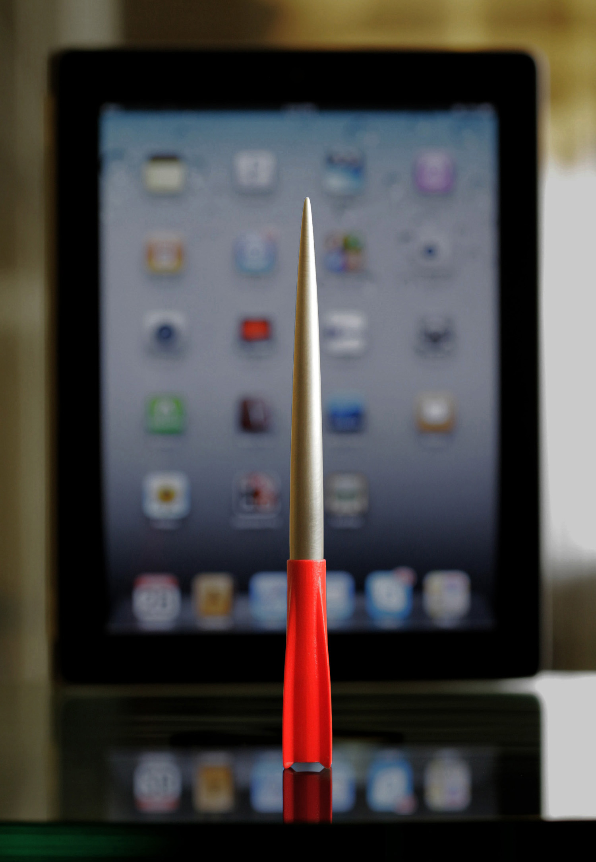
The GoSmart Stylus is the smoothest and most precise stylus for iPads, touchscreen tablets, smart phones and other devices. Made of ergonomically designed solid aluminum, the GoSmart Stylus features a flexible patent-pending see-through Teflon impregnated coated stainless steel tip with Capacitive Coupling Technology for precision pointing, perfect for painting, drawing, sketching, scribbling, writing, clicking, and selecting on any touchscreen device, even with sticky protective covers.

Pricing: $24.95
Website: www.justgosmart.com
Available at: http://justgosmart.com/store/ or through www.amazon.com
Release: http://www.thomas-pr.com/gosmart/gosmartstylusrelease.html
Photos:
GoSmart Stylus 200 Series: http://www.thomas-pr.com/136/photos/gosmartstylus200.html
GoSmart Stylus 300 Series: http://www.thomas-pr.com/136/photos/gosmartstylus300.html
Facebook: http://www.facebook.com/JustGoSmart

- ECO-CONSCIOUS GIFT WITH “GREEN” TECHNOLOGY & BEAUTIFUL DESIGN: Impecca Bamboo Custom Carved Designer Keyboard & Mouse

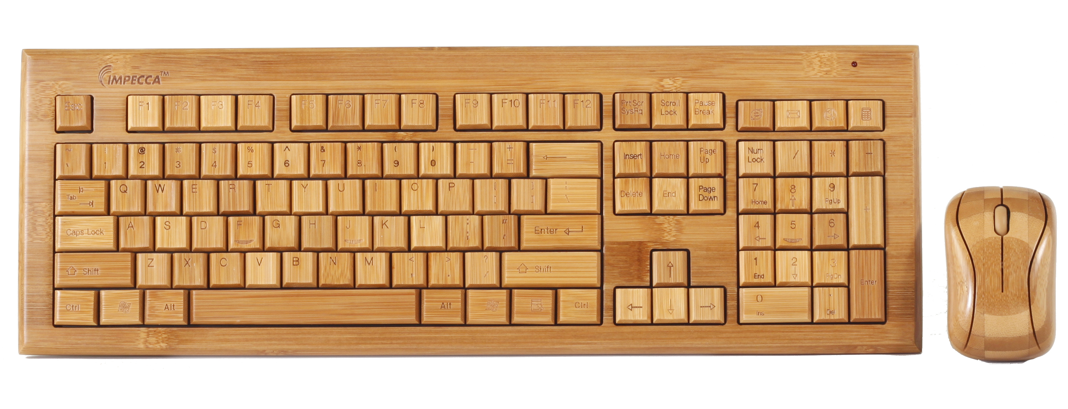
Created for the eco-conscious consumer, Impecca’s “green” Bamboo Keyboards and Mice are custom, hand carved 100% natural biodegradeable bamboo keyboard and mouse sets for work or home office. The USB keyboards and mice combine beautiful styling with “green” technology, featuring a wired keyboard/mouse in natural color and wireless keyboard/mouse in 4 colors: natural, cherry, mahoganny, and walnut that fit your décor. These elegant and well-designed bamboo products are the perfect accessory for any computer user, and are compatible with Windows and Mac.

Pricing: Wired $69.95, Wireless $99.95
Website: www.impeccausa.com
Available at: www.impeccausa.com and major retail stores
Photo: http://www.thomas-pr.com/136/photos/impeccabamboo.html
Info: http://www.impeccausa.com/bamboo/bamboo-keyboards/wireless-bamboo-designer-keyboard.html

- FOR KIDS, TEENS & ADULTS: Portable Animal-Themed Battery-Operated Stereo Systems for iPod, iPhone, and Other Cell Phones & Devices
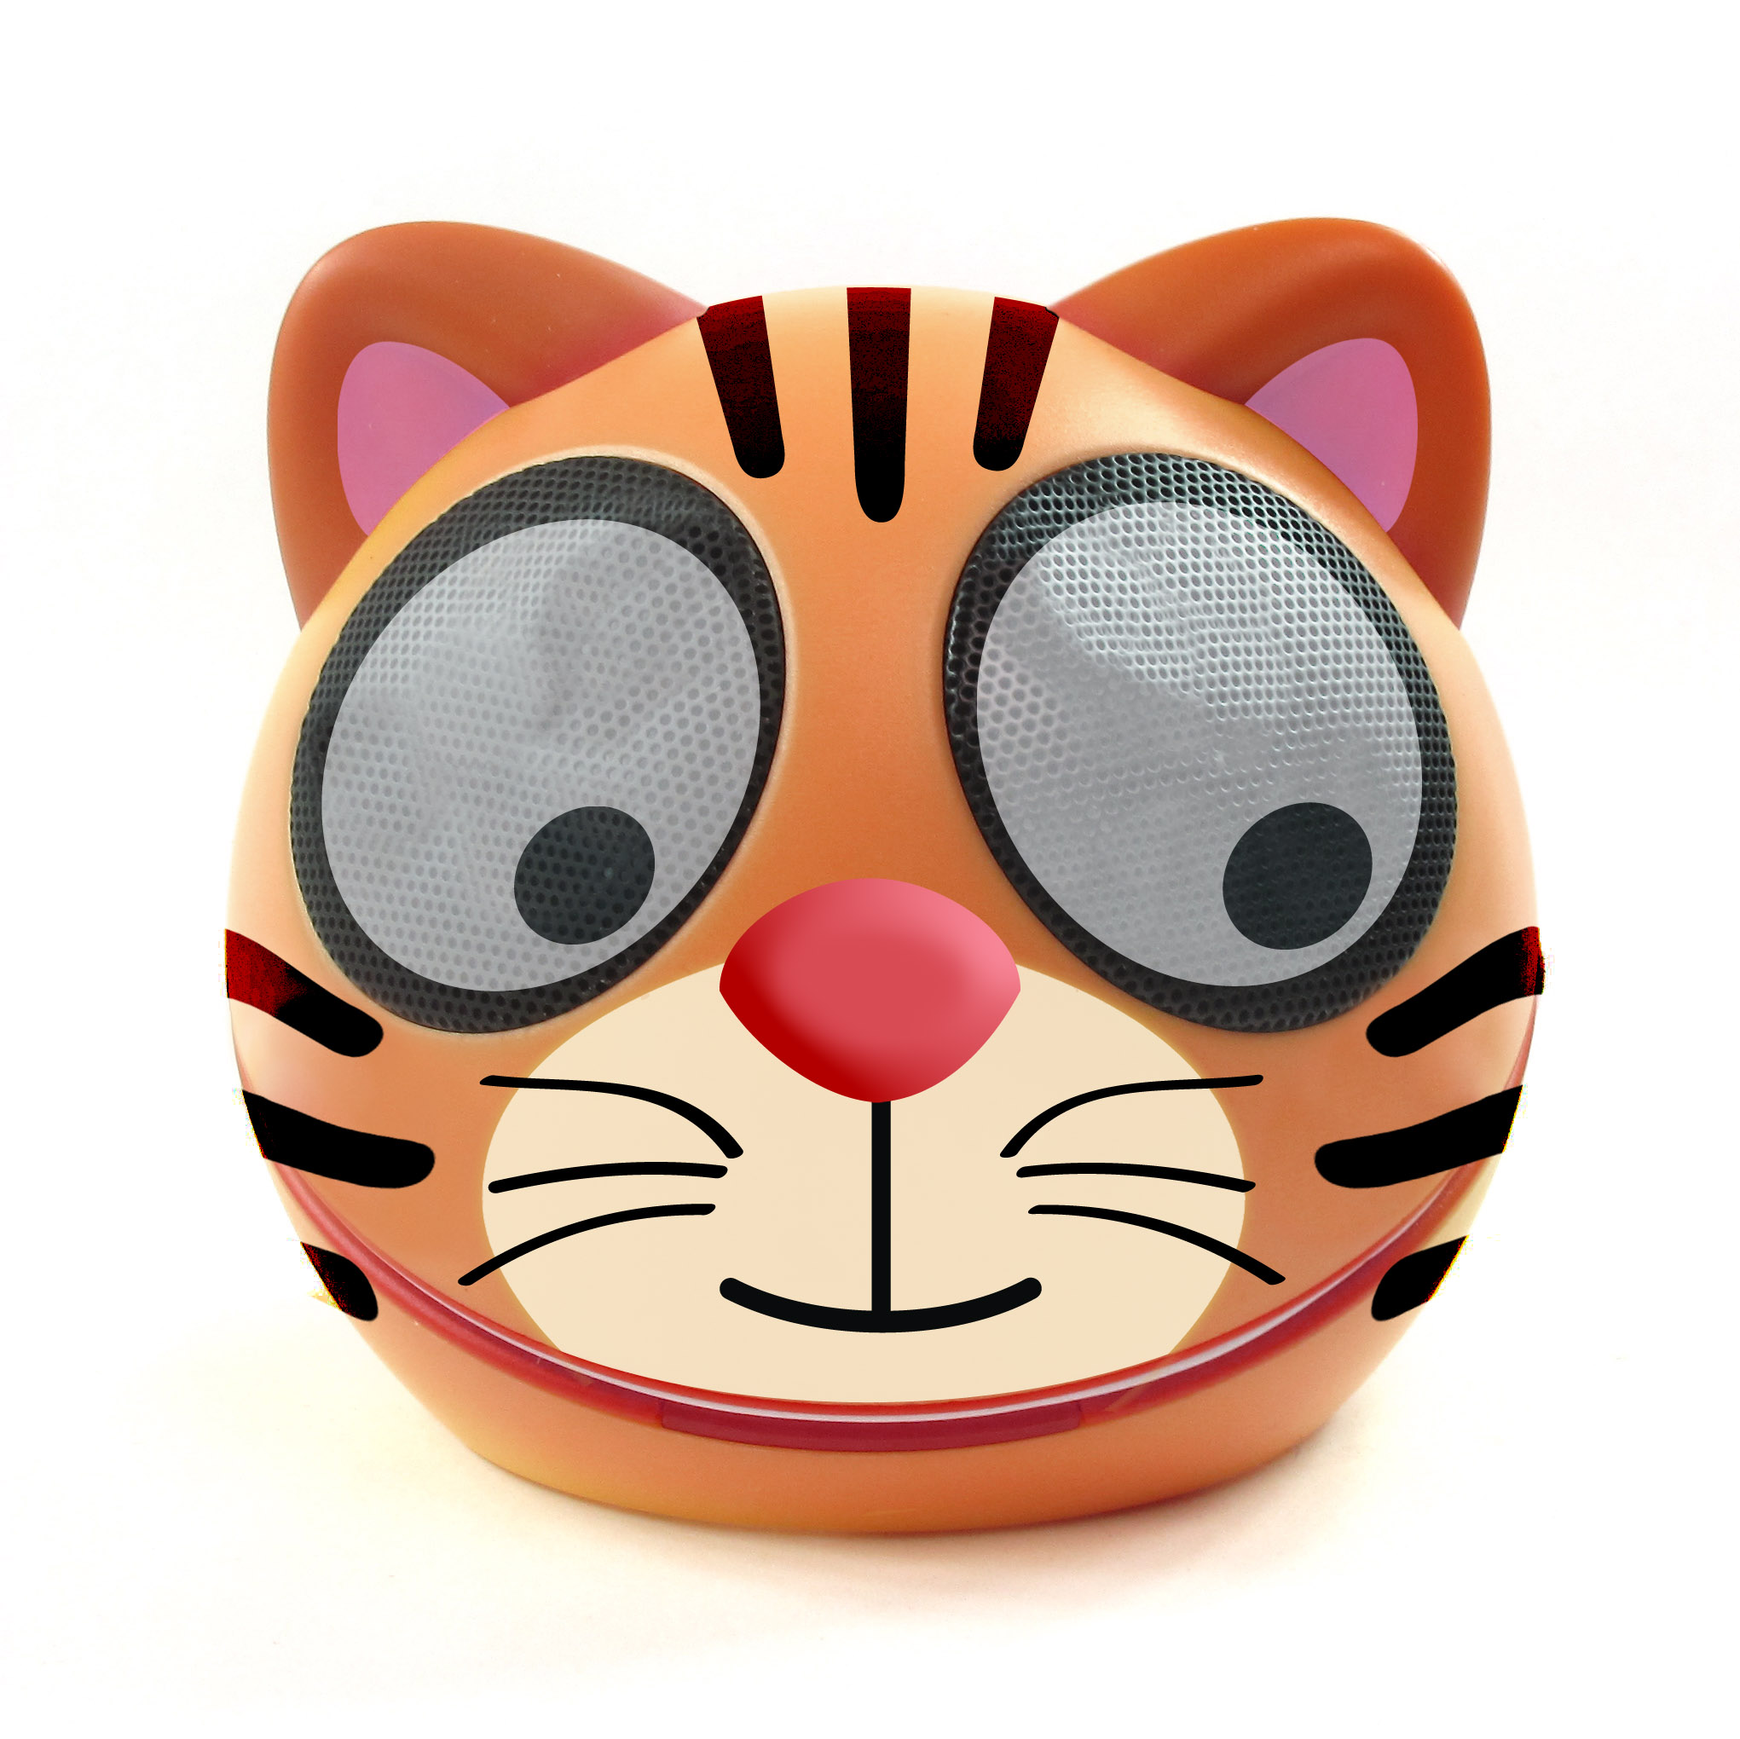
Impecca’s Zoo Tunes line of fun and fashionable animal themed portable speaker systems are stylishly designed, battery-operated compact portable speaker systems with excellent full-range sound performance. Zoo Tunes plugs into all iPods, iPhones and other smart phones, MP3/MP4 players, CD players, computers or other devices through its included 3.5mm jack or mini USB cable. The new Zoo Tunes line of portable speakers features a variety of designs, including tiger, kitten, bear, rabbit, pig, owl, and panda, which add fun and tuneful music to your home or office. Priced at just $24.99, Zoo Tunes fits in the palm of your hand, lightweight enough to pop in a bag for on-the-go use – at the beach, BBQ, party, office, or from room to room.

Pricing: $24.99
Website: www.impeccausa.com
Available at: www.impeccausa.com and major retail stores
Photos:
Zoo Tunes Tiger: http://www.thomas-pr.com/136/photos/impeccazootunestiger.html
Zoo Tunes Bear: http://www.thomas-pr.com/136/photos/impeccazootunesbear.html
Zoo Tunes Kitten: http://www.thomas-pr.com/136/photos/impeccazootuneskitten.html
Zoo Tunes Owl: http://www.thomas-pr.com/136/photos/impeccazootunesowl.html
Release: http://www.thomas-pr.com/impecca/impeccazootunesrelease.html

- FOR HIFI MUSIC AT PARTIES & ON THE ROAD: foxL PLATINUM Portable Bluetooth Speaker Created by a Rocket Scientist
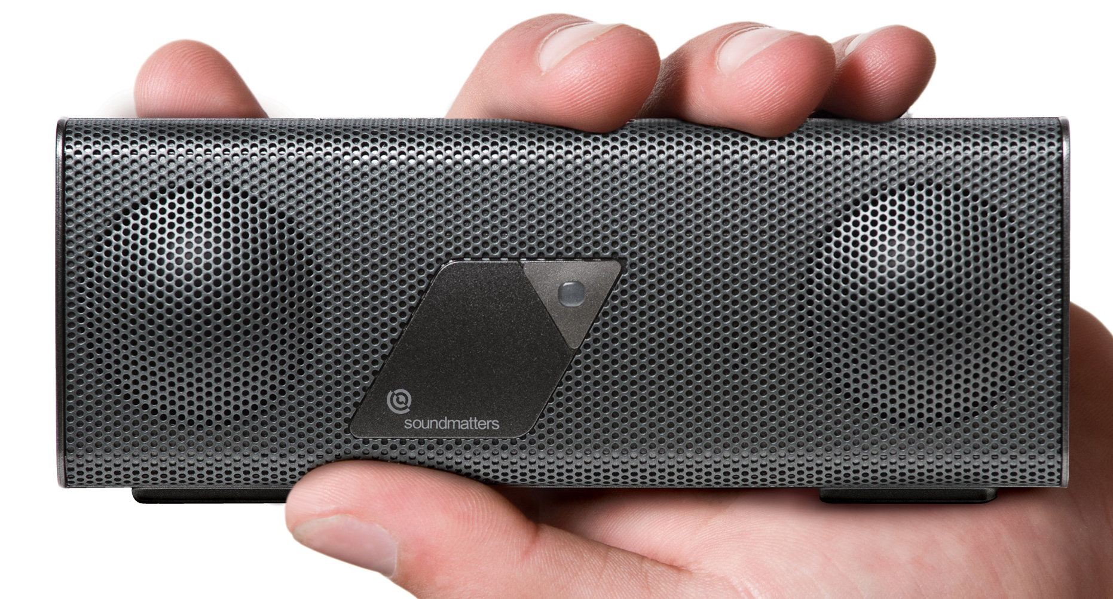
Everyone will want the portable foxLv2 PLATINUM as a holiday gift, the world’s best sounding tiny hi-fi Bluetooth speaker for iPad, iPhone, iPod touch, Android or other Bluetooth devices that fits in a pocket. Developed by former NASA engineer/audio legend Dr. Godehard Guenther, foxLv2 PLATINUM is the latest in the award-winning foxL series (TIME Magazine’s Top Ten Gadget of the Year). foxLv2 PLATINUM takes “go anywhere” listening to a new level with new performance features, including advancements in streamed Bluetooth for CD quality music, new audiophile cabling, and extended battery life. foxL PLATINUM is the only portable speaker capable of taking full advantage of CSR® apt-X’s dramatic improvement in streamed Bluetooth signal from apt-X equipped devices for virtual CD quality, along with improved sound/picture sync for movies and gaming. The perfect travel companion, you can bring foxL PLATINUM with you wherever you go on the road to listen to high quality music in a hotel room, at the beach, for presentations, and to listen to music in every room in the house without a stereo. Dream Theater Keyboardist Jordan Rudess, Guns N’ Roses Guitarist Richard Fortus and The Great Kat Shred Guitar Goddess use foxL as a personal practice amp.
Pricing: $249 foxL PLATINUM Special Edition
Website: www.soundmatters.com
Available at: www.soundmatters.com & online retailers, including Amazon.com, Frontgate.com, Crutchfield, Thinkgeek.com and more
Release: http://www.thomas-pr.com/soundmatters/soundmattersplatinumrelease.html
Photos:
http://www.thomas-pr.com/136/photos/soundmattersfoxlv2platinumalonewhite.html
http://www.thomas-pr.com/136/photos/soundmattersfoxlv2platinumhand.html
http://www.thomas-pr.com/136/photos/soundmattersfoxlv2platinumgirl.html
http://www.thomas-pr.com/136/photos/soundmattersfoxlv2platinumhand2.html
Facebook: http://www.facebook.com/pages/Soundmatters/114947155236305
YouTube: http://www.youtube.com/user/foxLspeaker
• FOR ARTISTIC TYPES: ArtRage for iPad, iPhone, Mac or PC – Art Software & App on the Go
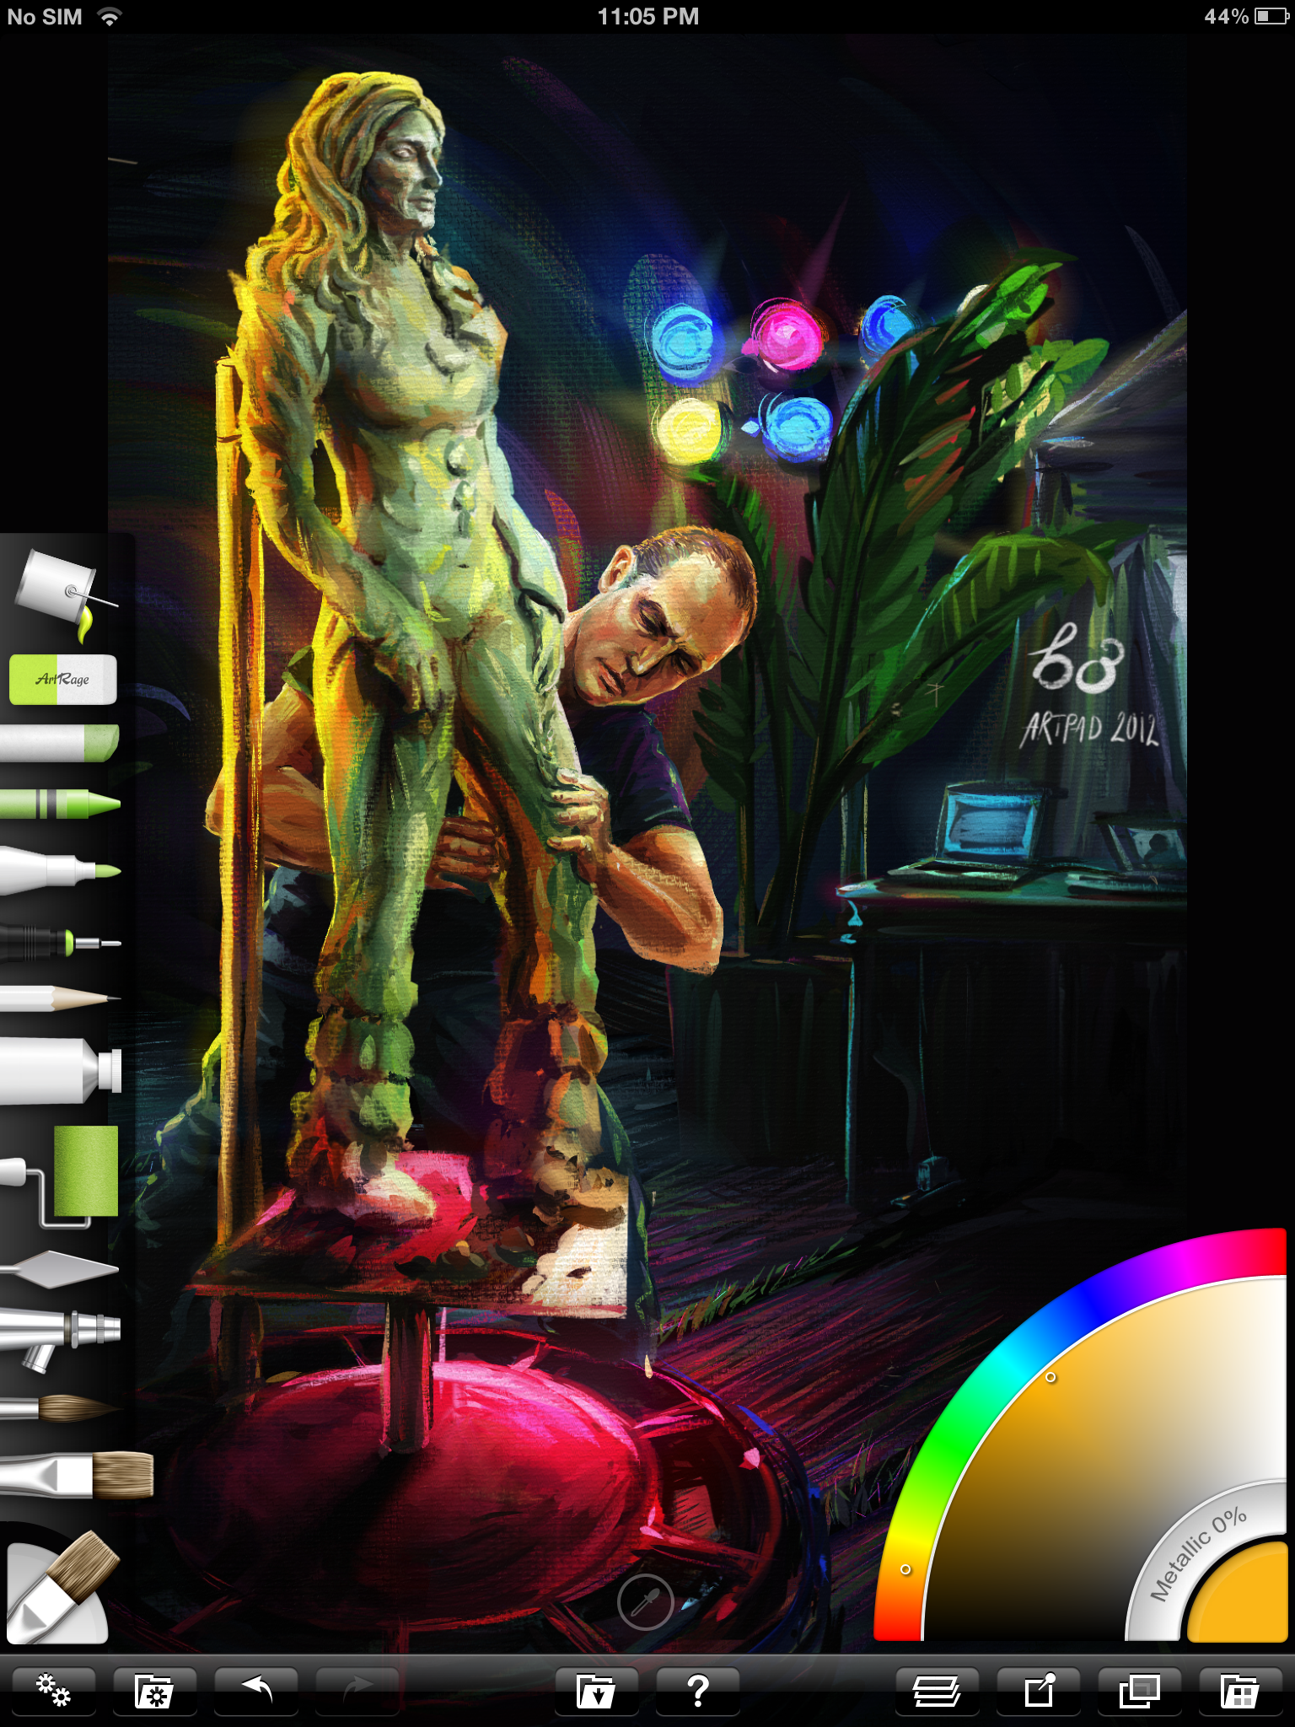
ArtRage lets anyone with an iPad, iPhone, Mac or PC become a digital artist. Upgraded for the new iPad’s full Retina high-res display, Ambient Design’s ArtRage lets creative people experiment with art, actually paint on an iPad or other digital “canvas” with oil painting effects that smear and blend and watercolor strokes that merge to create soft, wet gradations (available for iPad, iPhone, and Mac/Windows desktop computers).
Pricing: ArtRage for iPad: $6.99, ArtRage for iPhone: $1.99, ArtRage 3.5 Studio for Mac/Windows $29.90, ArtRage Studio Pro for Mac/Windows $59.90
Website: www.artrage.com
Available at: www.artrage.com & Apple iTunes Store
Release: http://www.thomas-pr.com/ambientdesign/artrageforipad14release.html
Photos: http://www.thomas-pr.com/136/photos/ambientdesignipadstarwar.html
http://www.thomas-pr.com/136/photos/ambientdesignipad.html
http://www.thomas-pr.com/136/photos/ambientdesignsculpture.html
YouTube: http://www.youtube.com/user/artragetv
Facebook: www.facebook.com/artrage Twitter: https://twitter.com/#!/ArtRage_Radar
• SOFT SHEEPSKIN MOUSE PAD TAKES OFF THE PRESSURE: GoSmart RestPad
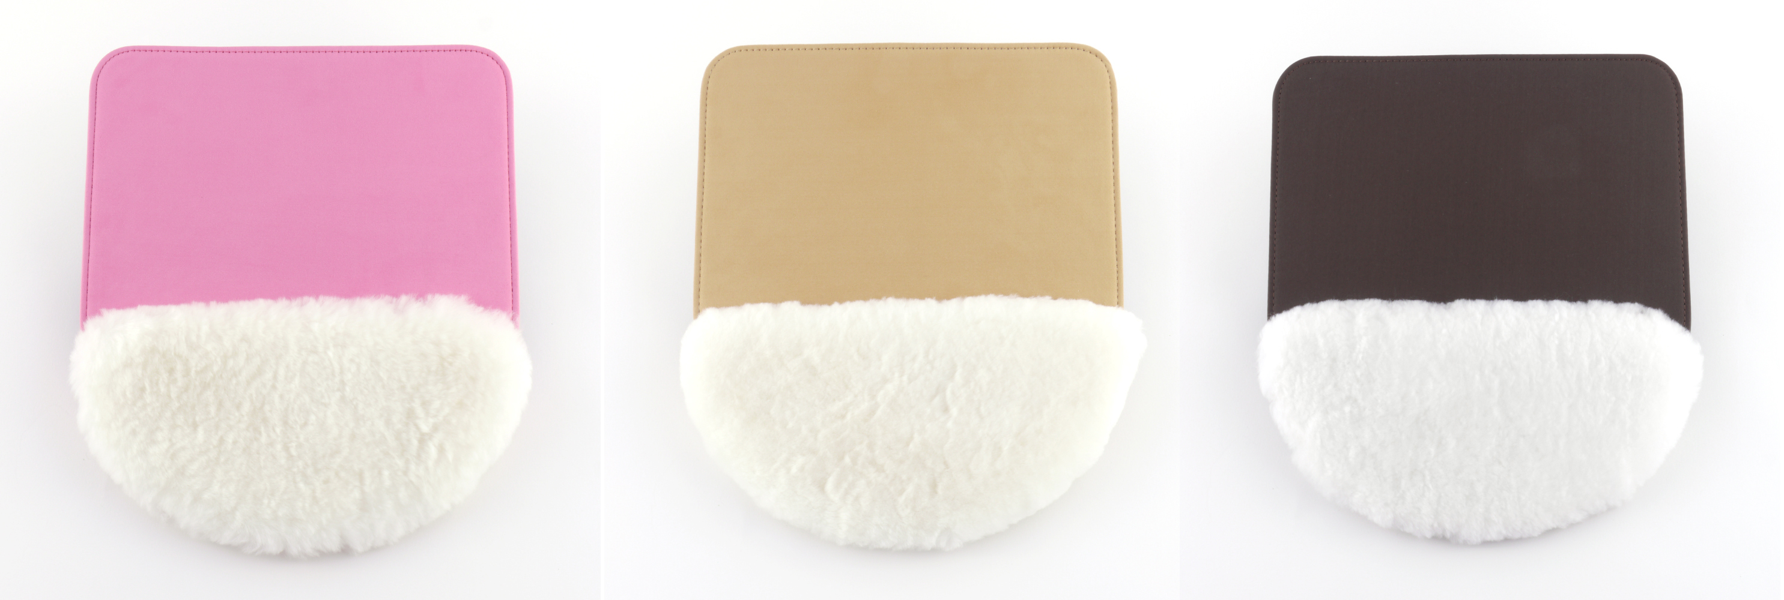
The GoSmart RestPad is an innovative new mouse pad with a luxurious sheepskin wrist rest designed to give soothing comfort and ultimate pressure relief while using a computer’s mouse. A perfect gift for anyone using a computer for hours a day or for those with repetitive wrist injury or Carpal Tunnel, the RestPad provides ultimate pressure relief, validated to relieve over twice as much pressure as other wrist rests, as tested with advanced tactile array sensors that measured the contact pressures underneath the wrist. The GoSmart RestPad fits your décor, available in tan microfiber, pink microfiber, or brown microfiber. Surprise your girlfriend, wife, friend, sister, or co-worker with the pink furry GoSmart RestPad or brown or tan RestPad as a gift and show that you care about their comfort!
GOSMART RESTPAD BENEFITS:
• Ultimate Pressure Relief
• Warm, Soft & Breathable Sheepskin
• High quality, large, and stable construction
• In Pink, tan or brown.

Pricing: $24.95
Website: www.justgosmart.com
Available at: http://justgosmart.com/store/ or through www.amazon.com
Release: http://www.thomas-pr.com/gosmart/gosmartrestpadrelease.html
Photos: GoSmart RestPad 3 Colors: http://www.thomas-pr.com/136/photos/gosmartrestpad3colors.html
GoSmart RestPad - Brown: http://www.thomas-pr.com/136/photos/gosmartrestpadbrown.html GoSmart RestPad - Beige: http://www.thomas-pr.com/136/photos/gosmartrestpadbeige.html
Facebook: http://www.facebook.com/JustGoSmart
Twitter: https://twitter.com/#!/justgosmart

- WATCHING MOVIES AND LISTENING TO MUSIC HAS NEVER BEEN BETTER: Kidz Gear Wired Headphones for Kids


The Award-winning Kidz Gear Headphones are now available in an assortment of fun colors to choose from, including pink, orange, blue, green, purple and the original gray. Parents will appreciate how the Kidz Gear Wired Headphones for Kids help keep children safe, quiet and busy while playing with their iPod, iPad, DVD player and other devices at home or on the road. They feature the unique KidzControl™ Volume Limit Technology for ensuring the safest listening experience while helping to protect children’s hearing.

Pricing: $19.99
Website: www.gearforkidz.com
Available at: www.Amazon.com, http://www.InMotionstores.com and www.GearForKidz.com
Facebook: http://www.facebook.com/pages/Kidz-Gear/117532751631705

- FOR MUSICIANS: The Great Kat - World’s Fastest Female Guitarist with Over 1 Million YouTube Views of Shred/Classical Music!



The Great Kat, the Juilliard Grad Violin Virtuoso/World’s Fastest Guitar Shredder, honored by Spin Magazine with a Star in the "GUITAR HERO GALAXY” (June 2012) and awarded “Top 10 Fastest Shredders of All Time” by Guitar One Magazine, is music that guitar shredders and rockers love. YOUTUBE Launches “YOUTUBE-THE GREAT KAT” CHANNEL at http://www.youtube.com/channel/HCuJG9jO1nSCE/featured with over 1 million YouTube views at http://www.youtube.com/user/KthomasPR. The Great Kat’s new “BEETHOVEN SHREDS” CD showcases Classical music shredded on the guitar & violin, including Beethoven, Bach, Paganini and more and is now featured in the new exhibit “AMERICA’S BEETHOVEN EXHIBIT” at The Ira F. Brilliant Center for Beethoven Studies at San Jose State University. The Great Kat has new instructional YouTube videos with Guitar Tablature/Music Notation, at:
-“The Flight of The Bumble-Bee” http://youtu.be/oteJe3Yum1I and http://youtu.be/sGUQyKBMklA
-Paganini’s “Caprice #24” http://youtu.be/6uDPPz12sFw
-Beethoven's “5th Symphony” http://youtu.be/JA2kmV4QH2I
-Bach’s “Brandenburg Concerto #3” http://youtu.be/9etszc4VjcQ

Pricing: “Beethoven Shreds CD: $7.95
Website: www.greatkat.com
Available at: Amazon: http://www.amazon.com/Beethoven-Shreds-Great-Kat/dp/B0055V0G9E/ref=sr_1_1?s=music&ie=UTF8&qid=1308161101&sr=1-1, Great Kat Website: www.greatkat.com, iTunes: http://itunes.apple.com/us/artist/great-kat/id384709526, and stores worldwide by Music Video Distributors: http://mvdb2b.com/s/GreatKatBeethovenShreds/TPR0006
Release: http://www.thomas-pr.com/greatkat/greatkatbeethovenshredsworldwide.html
Photos:
Beethoven Shreds CD Cover: http://www.greatkat.com/beethovenshredscd.jpg
The Great Kat Guitar Shredder: http://www.thomas-pr.com/greatkat/paganini2logo.jpg
Great Kat Guitar Tablature Photos: http://www.greatkat.com/08/guitartab/bachsbrandenburgconcerto59.jpg
http://www.greatkat.com/08/guitartab/beethovens5thsymphonyclip3.jpg
Facebook: http://www.facebook.com/greatkatguitarshredder Twitter: http://twitter.com/greatkatguitar
Youtube: http://www.youtube.com/user/KthomasPR


THE GREAT KAT “BEETHOVEN’S GUITAR SHRED” DVD

The Great Kat is the world’s fastest guitarist, named “Top 10 Fastest Shredders of All Time” by Guitar One Magazine. A Juilliard graduate violinist, The Great Kat combines metal and classical music for a speed thrill unchallenged in the music industry. She has been featured in the Jimmy Fallon site, NBC-Weekend Today in NY, Rolling Stone Magazine (Italy), Spin Magazine, New York Times, NewsBlaze and much more.
“Beethoven’s Guitar Shred” DVD Features 7 Outrageous Shred/Classical Guitar Music Videos, including:
- “The Flight Of The Bumble-Bee” - At the finger-blistering speed of 300 BPM!
- Beethoven’s “5th Symphony” - Metal version of the world’s most famous symphony!
- Paganini’s “Caprice #24” – Kat dazzles on this technical virtuoso showpiece on guitar and violin!
- Bach’s “Brandenburg Concerto #3”- The Great Kat shreds on 6 guitars & 3 violins!
Pricing: $9.95
Website: www.greatkat.com
Photo: http://www.greatkat.com/beethovensguitarshreddvd.jpg
DVD Trailer: http://www.greatkat.com/BeethovensGuitarShredVideosMenuMED.wmv
Available at major retailers and Amazon: http://www.amazon.com/Beethovens-Guitar-Shred-The-Great/dp/B001TIQUJW/ref=pd_sim_m_10 and The Kat Store: http://greatkat.com/store/page27.html
iTunes Downloads: http://itunes.apple.com/us/artist/the-great-kat/id368743108
Release: http://www.thomas-pr.com/pressreleases/beethovensguitarshredrelease.html



THE GREAT KAT “EXTREME GUITAR SHRED” DVD
The Great Kat Juilliard Grad/Violin Virtuoso introduces the ultimate guitar DVD, “EXTREME GUITAR SHRED.” In this brilliant DVD, The Great Kat dazzles audiences with finger-blistering guitar and violin virtuosity featuring 6 EXTREME GUITAR Music Videos with speed-defying guitar/violin shred versions of Classical Music Masterpieces!
“Extreme Guitar Shred” DVD Features:
- 6 Insane Extreme Guitar Shred Music Videos!
- 3 Shred Bonus Features! Hot Kat Photos! Shred FAQs!
- Speed-defying virtuoso guitar and violin Shred versions of Classical Music Masterpieces by Wagner, Liszt, Vivaldi, Bazzini and Sarasate.
Pricing: $9.95
Website: www.greatkat.com
Photo: http://www.greatkat.com/dvd/katdvdcover.jpg
DVD Trailer: http://www.greatkat.com/ExtremeGuitarShredDVDVideos.wmv
Available at major retailers and Amazon: http://www.amazon.com/Extreme-Guitar-Shred-The-Great/dp/B0007OIDBW/ref=pd_sim_m_13 and The Kat Store: http://greatkat.com/store/page2.html
iTunes Downloads: http://itunes.apple.com/us/artist/the-great-kat/id368743108
Release: http://www.thomas-pr.com/greatkat/extremeguitarshreddvdrelease.html
FOR REVIEW COPIES, CONTACT:
Contact: Karen Thomas/Eva Yutani
Thomas PR
kthomas@thomaspr.com / eyutani@thomaspr.com www.thomas-pr.com
631-549-7575 www.thomaspr.com

